Total revenue:

SELECT SUM(total_price) AS Total_Revenue

FROM pizza_sales

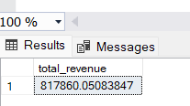

Average Order Value:

SELECT SUM(total_price)/ COUNT(DISTINCT order_id) AS Average_Order_Value

FROM pizza_sales



Total Pizza Sold:

SELECT SUM(quantity) AS Total_Pizza_Sold

FROM pizza_sales



Total Orders:

SELECT COUNT(DISTINCT order_id) AS Total_Orders

FROM pizza_sales



AS Average Pizza Per Order:

SELECT CAST(CAST(SUM(quantity) AS DECIMAL(10,2))/ CAST(COUNT(DISTINCT order_id) AS DECIMAL(10,2))AS DECIMAL(10,2)) AS Average_Pizza_Per_Order

FROM pizza_sales

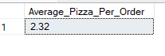

CHARTS:

CHART2:

SELECT DATENAME(DW,order_date) as order_day, COUNT(DISTINCT order_id) AS Total_Orders

FROM pizza

GROUP BY DATENAME(DW,order_date)

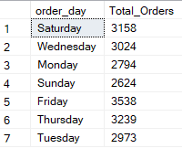

CHART 3:

SELECT DATENAME(MONTH, order_date) AS Month_Name , COUNT(DISTINCT order_id) AS Total_Orders

FROM pizza_sales

GROUP BY DATENAME(MONTH, order_date)

ORDER BY Total_Orders DESC

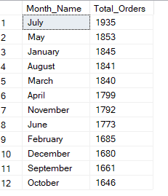

CHART 4:

SELECT pizza_category , SUM(total_price) AS Total_Sales, SUM(Total_Price)*100/

(SELECT SUM(total_price)FROM pizza WHERE MONTH(order_date) =1) AS PCT

FROM pizza

WHERE MONTH(order_date )= 1

GROUP BY pizza_category

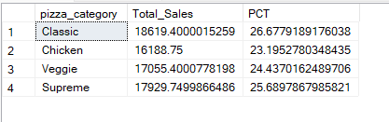

CHART 5:

SELECT pizza_size,CAST( SUM(total_price) AS DECIMAL(10,2))AS Total_Sales,

CAST(SUM(total_price)*100 / (SELECT SUM(total_price) FROM pizza WHERE DATEPART(quarter, order_date)=1) AS DECIMAL(10,2)) AS PCT

FROM pizza

WHERE DATEPART(quarter, order_date)=1

GROUP BY pizza_size

ORDER BY PCT DESC

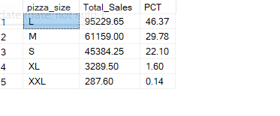

**F. Total Pizzas Sold by Pizza Category**

SELECT pizza_category, SUM(quantity) as Total_Quantity_Sold

FROM pizza_sales

WHERE MONTH(order_date) = 2

GROUP BY pizza_category

ORDER BY Total_Quantity_Sold DESC

***Output***

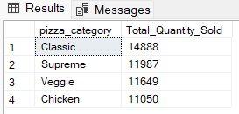

CHART6:

SELECT TOP 5 pizza_name, SUM(total_price) AS Total_Revenue

FROM pizza

GROUP BY pizza_name

ORDER BY Total_Revenue DESC

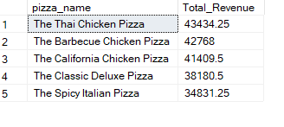

CHART 7:

SELECT TOP 5 pizza_name, SUM(total_price) AS Total_Revenue

FROM pizza

GROUP BY pizza_name

ORDER BY Total_Revenue ASC

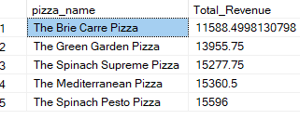

CHART 8:

SELECT TOP 5 pizza_name, SUM(quantity) AS Total_Quantity

FROM pizza

GROUP BY pizza_name

ORDER BY Total_Quantity DESC

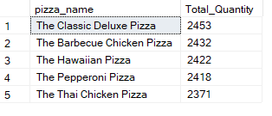

CHART 9:

SELECT TOP 5 pizza_name, SUM(quantity) AS Total_Quantity

FROM pizza

GROUP BY pizza_name

ORDER BY Total_Quantity ASC

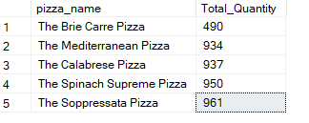

CHART:

SELECT TOP 5 pizza_name, COUNT(DISTiNCT order_id) AS Total_orders

FROM pizza

GROUP BY pizza_name

ORDER BY Total_orders DESC

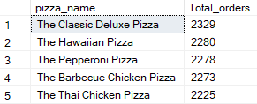

CHART:

SELECT TOP 5 pizza_name, COUNT(DISTiNCT order_id) AS Total_orders

FROM pizza

GROUP BY pizza_name

ORDER BY Total_orders ASC

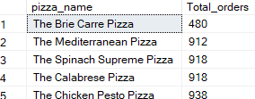

If you want to apply the pizza_category or pizza_size filters to the above queries you can use WHERE clause. Follow some of below examples

SELECT Top 5 pizza_name, COUNT(DISTINCT order_id) AS Total_Orders

FROM pizza_sales

WHERE pizza_category = 'Classic'

GROUP BY pizza_name

ORDER BY Total_Orders ASC